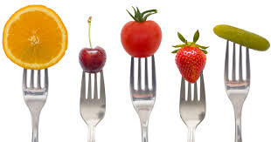

“Let Food be Thy Medicine, and Medicine Thy Food” ~Hippocrates

VICTOR VALLEY COLLEGE SYLLABUS

Spring 2020

Course No.: Biology 110 Course Title: Human Nutrition Units: 3.0
Section No.: 69494 Class Hours: 5:55 PM – 9:50 PM Days: T
Room No.: 33-158 Instructor Name: Dr. Harvey, PhD Office No.: 6

Victor Valley College
18422 Bear Valley Road
Victorville, CA 92392

Phone: (760) 245-4271, X 2658
e-mail: lisa.harvey@vvc.edu
Visit Victor Valley College online at www.vvc.edu

Spring Term Begins Tuesday, February 18
College Closed (no classes) April 10
Spring Break (no classes-offices open) April 13-17
Spring Break Weekend (college closed) April 18-19
Memorial Day Holiday (college closed) May 25
Commencement June 12
Spring Semester Ends June 13
Sixteen (16) week term February 18 – June 13
Off-Campus Sixteen (16) week term February 18 – June 13 (Does not follow VVC calendar, see that site’s calendar)
First Twelve (12) week term February 18 – May 16
Second Twelve (12) week term March 16 – June 13
First Eight (8) week term February 18 – April 11
Second Eight (8) week term April 20 – June 13

NOTE –CLASSES WILL NOT BE HELD ON CAMPUS THE FOLLOWING DATES: April 10th, 13th - 19th, and May 25^{tt}
STATEMENT OF ACCESS: Students with accessibility needs are encouraged to meet with instructors to discuss the opportunity for academic accommodation and referral to the ACCESS Resource Center per Administrative Procedure (AP 3440)

Withdrawal Policy
A student may drop or withdraw (or be dropped by an instructor), before the 44% point of the completion of the class. Students may not drop or be dropped after this point, and instructors must issue a grade beyond this point. A student who drops a class (or who is dropped by an instructor) on or prior to 20% of the course will have no record of that class on their permanent transcript, although they may still be responsible for payment of fees. Drops that occur after 20% of the course, and on or before 44% of a course, will result in a W symbol being entered. Students may be dropped for lack of attendance or for ‘good cause’ as defined in the Education Code, Article 3, Sect. 76033.

Course Description

Introduction to the medical aspects of nutrition, intended for students pursuing a career in health care. Biological function and chemical classification of nutrients. Nutritional needs throughout the lifespan. Effects of nutritional deficiencies and excesses. Recommended nutrient intakes and the role of diet in the development of chronic disease.

Student Learning Outcomes

Upon completion of the course the student should be able to:
- Explain the basis of the scientific method as it is used in developing hypotheses and theories, then apply the scientific method-based research, such as in peer-reviewed intervention, epidemiological, lab, and case studies, to the critical evaluation of nutrition-related literature and media, thus differentiating between proven scientific based research and myth.
- Describe the basic chemical structure of the six classes of nutrients and the substances therein; their action, interaction, and balance in relation to health and disease; and the process by which the human body ingests, digests, absorbs, transports, utilizes and excretes food substances.
- Judge the effect of nutrition and lifestyle factors that contribute to chronic diseases (and leading causes of death in the United States), then assess one’s own diet for nutritional adequacy, practically apply lifestyle changes, through food label-reading, food safety practices, and altered dietary choices, which are personalized for the individual’s nutrient and phytochemical needs based on health status, body weight differences and goals, sports performance, and differing lifecycle stages.

Prerequisites
None

Textbook(s)
Text: WARDLAW'S CONTEMPORARY NUTRITION
Needed for Class:
(1) Reef App

Incomplete
If a student has completed most of the course (75% or more) with a “C” or better average but is unable to complete the remainder of the semester due to extenuating circumstances (see student handbook), they may elect to take an incomplete (INC) for the course. You can make up all missing assignments. An incomplete does NOT allow you to repeat completed assignments. All missed assignments and exams must be completed by the following semester or the grade will revert to the one they would have earned at the end of this semester. It is the student’s responsibility to initiate the request for an incomplete. This must be completed in writing on a special school form and signed by both the instructor and the student before the end of the semester.

Examinations: Exams are mandatory. There will be 3 lecture exams, this includes your final exam. The exams are not cumulative and are approximately worth 150 points each. Exams will consist of multiple choice, short answer, and/or essay questions. These exams are concept-oriented and will cover the chapters listed for each. The only day for make-up exams is June 5 at 9:30am. This is a Friday so make appropriate arrangements.

Cell phones and all electronic devices will be turned off and put away during the exam. If you use your phone/electronic devices during the exam you will receive a zero on the exam as well as possible expulsion from the class.
PLEASE BE ON TIME FOR LECTURE EXAMS. If you are late, you will not get any extra time. You will not be able to take your exam, once the first student turns in their completed exam.

Any course work other than exams that are not picked-up a week after your final is given will be placed in the recycle bin.

PLEASE TAKE CAREFUL NOTE: During an exam there will be no leaving the classroom for any reason, except with a written Doctor’s excuse. If you leave the classroom your exam is over.

Lecture Quizzes: There will be iclicker(Reef) questions presented throughout the lecture period and added to your grade as quiz points. The student is responsible for having a Reef app and making sure to have it available for each class session. A Reef app must be registered by Feb 25, 2020. Without the app, you will not be allowed to answer the questions for points. Lecture quizzes will not be announced.

Case Studies: Case studies will be done in class and as homework. Any assignment sent home must be typed. Handwritten assignments will NOT be accepted.

Presentation: A power point presentation worth fifty (52) points will be required towards the end of the semester. This presentation will be done in a group. However, individual scores are not based on group performance.
Popular Press Article Summary-Due Week 4 (20 points): Students will select, read and summarize an article from a popular press source (magazine article/book/diet) that addresses a specific nutrition-related health condition (i.e. overweight/obesity, allergies, diabetes, etc.). Attach a copy of your article to your write-up. Make sure to site your article, as well as other articles you include in your summary. Your summary should be no less than one and no more than two typewritten pages.

Critical Review of Popular Press Nutrition Project-Due Week 8 (40 points): Students will critically analyze the conclusions of the popular press article (above) utilizing 2-3 research articles from the American Society of Nutrition journals (The Journal of Nutrition; American Journal of Clinical Nutrition; or Advances in Nutrition). The student will be responsible for determining the evidence basis of the popular press material and reviewing the scientific literature in support or against the advice. This review should be no less than three and no more than five typewritten pages. These pages do not include the Bibliography you will need to include at the end of your review.

Nutrition Behavior Change Project-Due Week 14 (60 points): The project will include: personal vision, goals, weekly action steps, and progress report. Details will be announced in week 3 section. There will be several small assignments throughout the semester and a larger summary assignment at the end of the semester. (my fitness pal)
These assignments will be counted towards your total grade.

I will send you e-mail updates on your grade throughout the semester. If you have any questions about your grade you must inform the instructor within five days of the grade posting. There will be no change in grades after the five days. This includes the final grade. So, make sure you check your grades frequently.

REEF Polling by i>clicker
I will be using REEF Polling by i>clicker in class this term. REEF Polling helps me to understand what you know, gives everyone a chance to participate in class, and allows you to review the material after class.
You will need to create a REEF Polling account to vote in class using your laptop, smart phone, or tablet connected to the university’s Wi-Fi. [You may also use your i>clicker remote in combination with your REEF Polling account.]

Creating Your REEF Polling Account
Go to http://reef-education.com or download the REEF Polling app for iPhone/iPad to sign up for a REEF Polling account. You should use your VVC email address and your student ID in the Student ID field. If you need to change your email address, password, or student ID, edit your account profile. Do not create and use more than one REEF Polling account as you will only receive credit from a single account.
Unless you will exclusively be using an i>clicker remote, you will need to purchase a subscription to use REEF Polling. You can use a credit card to purchase online, in-app purchase, or buy an access code from the bookstore. Creating a REEF Polling account automatically starts a free 14-day trial subscription.

Add a Clicker to Your REEF Polling Account
If you want to use your i>clicker + or i>clicker 2 remote, you must register it with your REEF account. Register your clicker by logging into REEF Polling, navigate to your profile, and then enter your 8-character clicker ID. You may use either your smart device or registered clicker to vote in classroom polls throughout the term and will be able to review your session history no matter which device you use.
Add This Course to Your REEF Polling Account
Search with the following information to find this course and add it to your REEF Polling account:
Institution: Victor Valley College
Course: Biol 110_Spring 2020_73806

Cheating
I consider submitting votes for a fellow student to be cheating and a violation of the College Honor Code. If you are caught voting for another student or have votes in a class that you did not attend, you will forfeit all REEF Polling point and may face additional disciplinary action.

Podcasts and Recordings:
All classroom lectures will be recorded for posterity. All notes along with new class casts are located at http://www.bloodhoundsincorporated.com
Grades
The percentage scale is as follows (No exceptions):
90 – 100% = A
80 – 89.9% = B
70 – 79.9% = C
60 – 69.9% = D
59.9 and below = F

Classroom Policies:

Etiquette and Ethics
Although extenuating circumstances occur, and you must be late to class, do your best to arrive to class on time. If for some reason you cannot arrive at the assigned time, then please enter the classroom quietly and have consideration for other students and the instructor. Because we are also in an intimate classroom setting any extraneous talking is not appreciated during lecture because it is very distracting to your fellow students and even the instructor.

Please read the college policy on cheating and plagiarism. Academic dishonesty in any form will not be tolerated and may result in failure of an exam/assignment, failure of the course or expulsion from the college. If you have any questions regarding dishonesty or are in anyway unclear about the meaning of the college policy, please see me immediately. If Academic Dishonesty is observed in the classroom, the assignment will be given a grade of “F” and the student will be expelled from the class for two days.

Children
It is the policy of Victor Valley College that children NOT attend class with their parents nor be left unattended on campus while parents attend class. If you qualify, there is a day-care center on campus, if not, please make arrangements for a babysitter.

No food or drinks
It is school policy that NO food or drinks be allowed in the classroom. Please do not use
the small sinks and drawers at the desk as trash receptacles. It is also important to leave all open foodstuffs outside of the classroom, we tend to collect a large herd of ants after a while. It is not pleasant having them crawl up your pant leg!!!

PLEASE NOTE: It is the responsibility of every person at each table to make sure the tabletop is clean after the class session is over. It is also the responsibility of every person at the table to check the sink and drawers to make sure there is not trash in either.
After a laboratory procedure, it is also the responsibility of everyone at the table to make sure the floors are swept and mopped. If you do not make sure your table and the area around your table is clean there will be a 10-point deduction from every person sitting at that table after any or all class sessions.

Lecture Schedule
A tentative lecture schedule with approximate dates for lecture topics and examinations is included in this syllabus. Materials may be covered at a faster or slower pace, depending upon the circumstances. It is the responsibility of the student to note any and all changes. The chapters indicated for exams should be read prior to the day of the exam

Recordings:
All classroom lectures may be recorded for posterity.

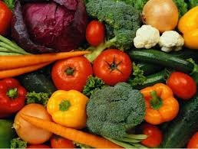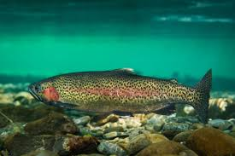

Date Lecture Topics Chapter
Feb 18 Nutrition, Food Choices and Health 1 Carbohydrates 4
Lipids 5
Proteins 6
Overview of Micronutrients and Phytochemicals 8
March 24 Exam 1 Nutrients Involved in Body Defenses 10
Nutrients Involved in Bone Health 11
Micronutrient Function in Energy Metabolism. 12
Nutrients that Support Blood and Brain Health. 13
Eating Disorders 14

May 12 Exam 2
Safety of Our Food Supply 17 Nutrition During Pregnancy and Breastfeeding. 18
Nutrition from Infancy to Adolescence 19
Nutrition During Adulthood 20

June 9 Final Exam

LECTURE SCHEDULE

Feb 18 Introduction/ Nutrition, Food Choices and Health

Feb. 25 Carbohydrates
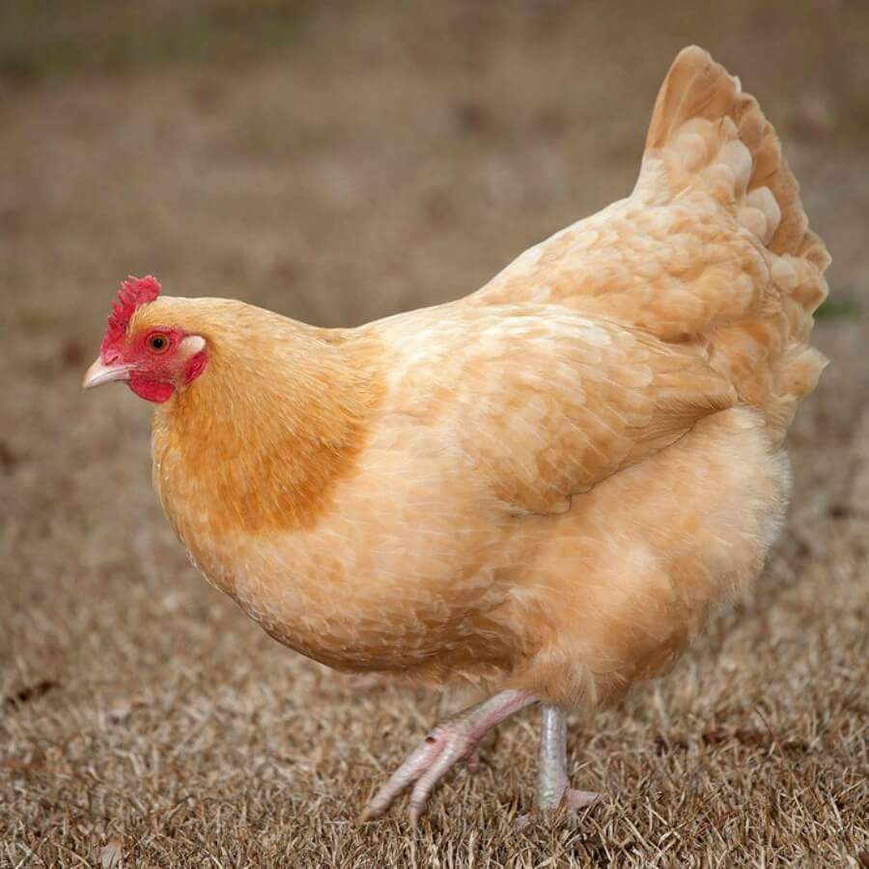
March 3 Fats

March 10 Proteins

March 17 Fluid and Electrolytes

March 24 Exam 1

March 31 Nutrients Involved in Body Defenses

April 7 Nutrients Involved in Bone Health

April 14 Spring Break

April 21 Micronutrient Function in Energy Metabolism

April 28 Nutrients that Support Blood and Brain Health

May 5 Eating Disorders

May 12 Exam 3

May 19 Safety of Our Food Supply

May 26 Nutrition During Pregnancy and Breastfeeding

June 2 Nutrition from Infancy to Adolescence to Adulthood

June 9 Final Exam

Instructions for Completing the Diet Analysis Project

Watch the following youtube video to learn how to set up the app you will be using on your cell phone, tablet or computer. The app is called my fitness pal and you can download it for free. Here is the website for the tutorial. https://www.youtube.com/watch?v=MBpVBn4WAtk

Can I print my diary from the app?
You can view a printable version of your diary by logging into your account on our website at http://www.myfitnesspal.com Mobile app users should log in using the same username and password they use in the app.
Once you've logged in, click the "Food" tab. Scroll to the bottom of the page and click "View Printable Report." Choose a date range and click "Change Report."
If using an app, you may also want to try taking a screen shot of the information you'd like to print and then email yourself the screen shot and then print.
As an alternative to printing your diary for your doctor or nutritionist, you may want to also want to consider sharing your diary. Please see: https://myfitnesspal.desk.com/customer/portal/articles/201687
If you are a Premium member, one of the features of Premium is data exporting: https://myfitnesspal.desk.com/customer/en/portal/articles/2457070-data-export-faqs,
For more info regarding Premium, please see: https://myfitnesspal.desk.com/customer/en/portal/articles/1935024-what-are-the-features-of-myfitnesspal-premium-
Keep your food and exercise diary every day for three weeks.
List of Reports Needed:

❖ Calories
❖ Carbs,
❖ Fats – Saturated, Polyunsaturated, and Trans Fat
❖ Proteins, Cholesterol and Fiber
❖ Sodium, Potassium, Calcium and Iron
❖ Exercise Diary

SAVE a copy of each of the reports (see list above). You will use these to prepare your FINAL diet analysis report:

Congratulations! You now HAVE all the reports needed to complete the Diet Analysis Project.

USE instructions below to EVALUATE these reports and complete the assignment.

● Instructions for Composing a Professional EVALUATION of the Client's Diet with Recommendations for Improvement.

1. Type this report using MS Word or a similar software. Your “Evaluation” statements should be no more than ONE page (size 12 font) in length. Tables or lists should be given on a separate page.

2. Use the reports to complete this assignment.

3. Imagine that you are the professional nutritionist and you are analyzing the diet of a client (do NOT use first person).

4. Use the “NUTRIENT REPORTS” to evaluate the macronutrient ranges. State whether the client has the right (balance) percentages of carbohydrate, fat, and protein in the diet. HINT: you will need to look up the target ranges along with the actual percentages.

5. Use the same report to identify individual nutrients with "actual" amounts that were too low, too high, and just about right (deficiencies, excesses, and adequacies). On a separate page, make a table or 3 separate lists. On one list or another, include the names of ALL nutrients that appear in the printed report.

6. For those components that are much too high, use the Food reports (one for each day) to determine which specific foods and/or beverages were responsible for providing high amounts. Do this for each nutrient in question, such as sodium, protein, fat, etc.

7. For nutrients that are much too low, use the textbook to determine foods that can be added to the diet, in the future, to increase the client’s intake. Do this for each nutrient in question.

8. Evaluate the “Food Groups” results. Keep it brief.

9. Summarize your recommendations: Give advice for how the client can improve the nutritional quality of the diet and overall health. Be sure to compliment the client on those features of the diet that are right on-target (90-110%). Keep it at just ONE short paragraph.

NUTRITIONAL PRESENTATION

- Your presentation should be no longer than 30 minutes and no shorter than 25 minutes, with a 2-minute question and answer session.

- Your presentation will be created on power point. The power point presentation will include the following:

- You will utilize and develop research skills, critical thinking, and application of course material by doing a literature review of a diet of your choice.
- Include a nutritional analysis of the diet and how the diet effects human health, which include both physical and mental health.

- You will be required to have a Bibliography included on your power point. Your Bibliography must contain no less then 5 references and 3 of these five must be from journal articles. Do not limit yourself to the Merck Manual and Taber’s Medical Encyclopedia. You may reference the internet, but the sources must be legitimate. For example, emedicine.com, nih.gov, cdc.gov, pubmed.com. You may not use anyone’s personal web site, except to obtain pictures.

- When presenting you may NOT use reference materials such as 3 x 5. You are expected to memorize your information and present it in an appropriate fashion to the class. Your power point slides should be used as 3X5 cards. But beware, if you pack your slide with too much information you will be counted down. Each slide should have just a little information for the audience and you supply the rest from your knowledge. The idea is to know your stuff and give an interesting presentation.

- Your PowerPoint needs to be emailed to me prior to your presentation. You will be graded based on your presentations alone. Your grade is NOT based on your group’s presentation.

EXAMPLES OF DIETS

- Mediterranean
- Atkins
- Modified Atkins
- Blood Type Diet
- South Beach Diet
- Weight Watchers
- Pritikin Diet
- Ketogenic Diet
- Pickle Diet
- Zone Diet
- Vegetarian Diet
- Raw Food Diet
- Vegan Diet
- Crash Diet
- Detox Diet
- Belief Based Diet
- Fruitarian Diet
- Lacto vegetarianism
- Ovo-lacto vegetarianism
- Kangatarian
- Pescetarian
- 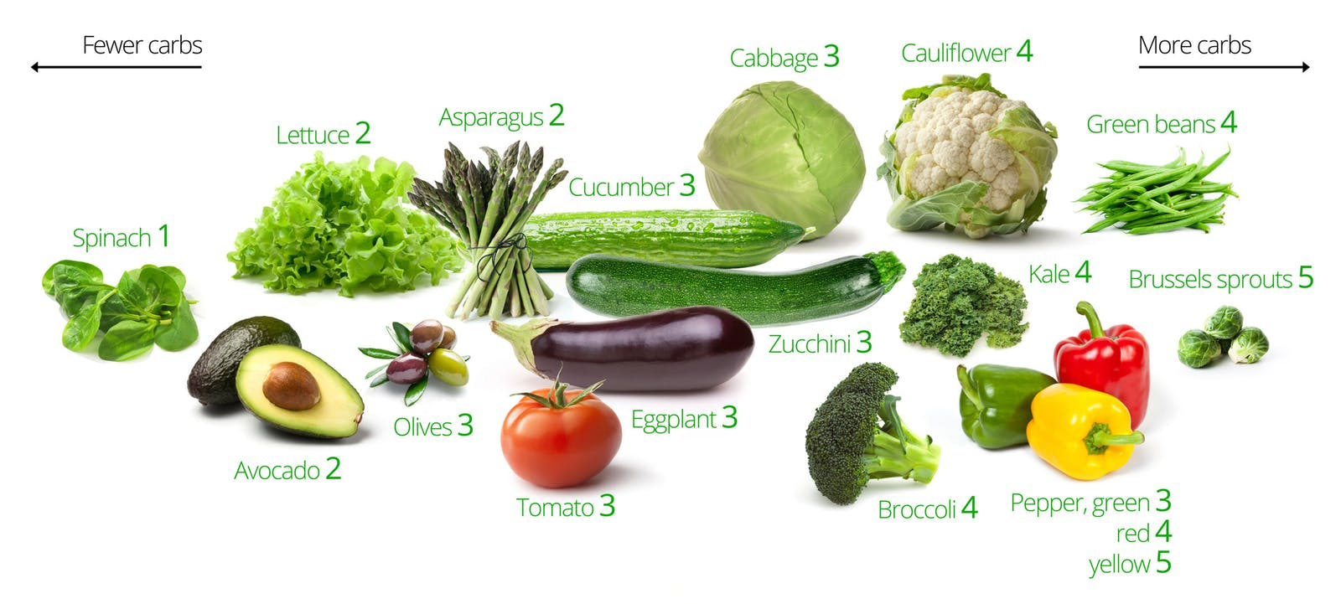Plant based Diet
- Pollotarian
- Pollo-pescetarian
- Intermittent fasting
- Body for LIfe
- Cookie diet
- The Hacker’s diet
- Nutrisystem
- Inedia
- KE diet
- Dukan Diet
- Ideal Protein diet
- Kimkins
- Stillman diet
- Beverly Hills diet
- Cabbage Soup diet
- Grapefruit diet
- Monotrophic diet
- Subway diet
- Western dietary pattern
- Juice fasting
- Master cleanse
- Buddhist diet
- Hindu diet
- Jain diet
- Islamic diet
- I-tal
- Kosher diet
- Seventh day Adventist diet
- Diabetic diet
- DASH diet
- Elemental diet
- Elimination diet
- Gluten-free diet
- Liquid diet
- Alkaline diet
- Clean eating diet
- Fit for Life diet
- Food combining diet
- Hay diet
- High protein diet
- Jenny Craig
- Low fat diet
- Low glycemic index diet
- Macrobiotic diet
- MIND diet
- Paleolithic diet
- Prison loaf
- Raw foodism
- Scarsdale medical diet
- Slow-carb diet
- Tongue patch diet
- Sugar busters
- SparkPeople diet

