

**VICTOR VALLEY COLLEGE**

WINTER SEMESTER 2020

# HUMAN BIOLOGY

**Victor Valley College**

**18422 Bear Valley Road**

**Victorville, CA 92392**

## Phone: (760) 245-4271, x2658

**e-mail:** [**lisa.harvey@vvc.edu**](mailto:lisa.harvey@vvc.edu)

#### Course No.: Biol 107 Course Title: Human Biology Units: 4.0

**Room No.: 31-1 Hours: 9:00 – 11:55am Days: M-TH**

**Section No.: 72855 Office No.: 6**

## Visit Victor Valley College online at www.vvc.edu

**WINTER CALENDAR**

Classes Start January 6, 2020

Holiday January 20, 2020

Classes end February 13, 2020



#### Course Description

This course is an introduction to biological principles with a human perspective. There will be an emphasis on cellular structure and function, organ systems, the concept of homeostasis, adaptation, cellular and population genetics, and the interaction of the human species with the ecosystem.

**Student Learning Outcomes**  
Upon completion of the course the student can:

1. Contrast the forms and functions of selected human organ systems from the molecular/cellular level to homeostasis at the organismal level.
2. Use scientific reasoning to evaluate the biological principles underlying current human health dilemmas, such as the causes of disease, use of biotechnologies, management of epidemics and public health, ecological/environmental health, and social health inequities.

#### Prerequisites

No prerequisites

**Required Textbooks/Supplies**

1. Mader, S. and Windelspecht, M., *Inquiry Intro Life*, 15th Edition, McGraw Hill Publishers, 2018.
2. Mader, S., Laboratory Manual for *Inquiry Intro Life,* 15th Edition, McGraw Hill Publishers, 2018.
3. Nitrile gloves – One box per table to be used during dissections
4. Scantrons-882E (5-6 Forms) – No compatible forms will be accepted.
5. Recommended: 3 X 5 cards for flash cards and a recording device

#### Attendance

Attendance is required and is the responsibility of the student. If you do not attend the first-class session, the instructor may drop you. **IT IS THE STUDENT’S RESPONSIBILITY TO DROP THIS CLASS.** If you do not plan to continue to attend class, you must drop the course to avoid receiving and “F” grade. Two unexcused lecture and/or laboratory absences will result in dismissal from the class.

#### Withdrawal Policy

It is the student’s responsibility to officially withdrawal from this class. **DO NOT** simply stop coming to class and expect the professor to drop you. Not withdrawing from class may result in an “F” grade for the class. If you take a “W” for the course, no assignments are carried into the next semester. You must repeat the class!

#### Incomplete

If a student has completed most of the course (75% or more) with a “C” or better average but is unable to complete the remainder of the semester due to extenuating circumstances (see student handbook), they may elect to take an incomplete (INC) for the course. You are allowed to make up all missing assignments. An incomplete does **NOT** allow you to repeat completed assignments. All missed assignments and exams must be completed by the following semester or the grade will revert back to the one they would have earned at the end of this semester. ***It is the student’s responsibility to initiate the request for an incomplete.*** This must be completed in writing on a special school form and signed by both the instructor and the student before the end of the semester.

**Explanation of Graded Assignments:**

**Quizzes:** Quizzes are unannounced and will be given anytime during the lecture and or lab portion of the class. Please have a pack of small scantron forms available for quizzes, but also be prepared just to use plain paper to write out a response. I don’t give make up quizzes; you will lose the points if you are not present. If you’re not present when the quiz is handed out, you will not be allowed to take the quiz, arrive on time.

**Lecture Examinations: {**800 points} Lecture exams will be given in class and will consist of multiple-choice questions and essay type questions. Each exam is worth a total of 200 points, you will need the green scantron forms #882E for each exam.

**Laboratory:** Lab attendance is mandatory.If you know that you will miss a lab you need to notify me ahead of time. To account for lab attendance, I will sign your lab write up after each lab. If your lab is not signed after each lab activity, I will assume that you were not present that day and you will get a zero for the write-up. The labs are supplemental means of instruction. They provide hands on experience to the topics we will cover during lecture. Lab activities can be found on the website.

**Lab Practical Exams:** {200 points} Laboratory practical examswill be given. These exams will be conducted in a laboratory setting in which students will rotate through many stations set up with a dissected pig, microscope, or bone models and etc. You will be expected to identify anatomy, answer physiological questions (functions), or identify histological cells, organelles & structures on the microscope. Practicals require a great deal of time to set up and therefore cannot be made up under any circumstances.

**Lab Write-up:** I will sign off on your lab before you leave. If you leave without my signature you will not get credit for the lab. If you are absent from lab, you will not be able to turn in the lab assignment for that day. You will lose 2 lab points for each lab you do not attend or leave early, no matter the reason.

**Lab Quizzes**: There will be quizzes in lab. This will cover what you will be doing in lab. These quizzes will be approximately 10-15 minutes long and will start at the beginning of lab. I do not give make-up lab quizzes. If you are late to lab you will only have whatever time remains to complete the quiz.

**Examinations:** **Exams are mandatory.** There will be 4 lecture exams, this includes your final exam. The exams are not cumulative and are approximately worth 150 points each. Exams will consist of multiple choice, short answer, and/or essay questions. These exams are concept-oriented and will cover the chapters listed for each. The **MAKE-UP** exam will be held on Friday February 7, 2020 at 9:30am.

Cell phones and all electronic devices will be turned off and put away during the exam. If you use your phone/electronic devices during the exam you will receive a zero on the exam as well as possible expulsion from the class.

**PLEASE BE ON TIME FOR LECTURE EXAMS**. If you are late, you will not get any extra time. You will not be able to take your exam, once the first student turns in their completed exam.

**PLEASE TAKE CAREFUL NOTE: During an exam there will be no leaving the classroom for any reason, except with a written Doctor’s excuse. If you leave the classroom your exam is over.**

**Lecture Quizzes:­** There will be *iclicker* questions presented throughout the lecture period and added to your grade as quiz points. The student is responsible for having an *iclicker* app and making sure to have it available for each class session. An *iclicker* app must be registered by **Jan 8**, 2020. Without the app you will not be allowed to answer the questions for points. Lecture quizzes will not be announced.

**Connect Quizzes Online**

You will also be responsible for assignments found at the following web address: <https://connect.mheducation.com/class/h-lisa-biol107-2020wi-syllabus-72855-1>

These assignments will be counted towards your total grade.

I will send you e-mail updates on your grade throughout the semester. ***If you have any questions about your grade you must inform the instructor within five days of the grade posting. There will be no change in grades after the five days***. **This includes the final grade.** So, make sure you check your grades frequently.

**Grades**

The percentage scale is as follows:

90 – 100% = A

80 – 89.9% = B

70 – 79.9% = C

60 – 69.9% = D

59.9 and below = F

**REEF Polling by i>clicker**

I will be using REEF Polling by i>clicker in class this term. REEF Polling helps me to understand what you know, gives everyone a chance to participate in class, and allows you to review the material after class.

You will need to create a REEF Polling account to vote in class using your laptop, smart phone, or tablet connected to the university’s Wi-Fi. [You may also use your i>clicker remote in combination with your REEF Polling account.]

**Creating Your REEF Polling Account**

Go to <http://reef-education.com> or download the REEF Polling app for iPhone/iPad to sign up for a REEF Polling account. You should use your VVC email address and your student ID in the Student ID field. If you need to change your email address, password, or student ID, edit your account profile. Do ***not*** create and use more than one REEF Polling account as you will only receive credit from a single account.

Unless you will exclusively be using an i>clicker remote, you will need to purchase a subscription to use REEF Polling. You can use a credit card to purchase online, in-app purchase, or buy an access code from the bookstore. Creating a REEF Polling account automatically starts a free 14-day trial subscription.

**Add a Clicker to Your REEF Polling Account**

If you want to use your i>clicker + or i>clicker 2 remote, you must register it with your REEF account. Register your clicker by logging into REEF Polling, navigate to your profile, and then enter your 8-character clicker ID. You may use either your smart device or registered clicker to vote in classroom polls throughout the term and will be able to review your session history no matter which device you use.

**Add This Course to Your REEF Polling Account**

Search with the following information to find this course and add it to your REEF Polling account:

Institution: Victor Valley College

Course: Biol 107_Winter2020_72855

**Reef Quiz Cheating**

I consider submitting votes for a fellow student to be cheating and a violation of the College Honor Code. If you are caught voting for another student or have votes in a class that you did not attend, you will forfeit all REEF Polling point and may face additional disciplinary action.

**Classroom Policies:**

#### Etiquette and Ethics

Although extenuating circumstances occur and you must be late to class, do your best to arrive on time to class. If for some reason you cannot arrive at the assigned time, then please enter the classroom quietly and have consideration for other students and the instructor. Because we are also in an intimate classroom setting any extraneous talking is not appreciated during lecture because it is very distracting to your fellow students and even the instructor.

**I DO NOT TOLERATE CHEATING!!!** The Biology Department takes all incidences of academic dishonesty seriously and acts accordingly. **If you are caught cheating, you will receive a zero on the assignment.** **Ignorance of *what* cheating is will not be accepted as an excuse.**

The following is taken verbatim from the Victor Valley College Student Handbook:

The term cheating includes but is not limited to:

* Use of any unauthorized assistance in taking quizzes, tests, or examinations;
* Dependence upon the aid of sources beyond those authorized by the instructor in writing papers, preparing reports, solving problems, or carrying out other assignments or- acquisition without permission, of tests or other academic material belonging to a member of the Victor Valley College faculty or staff.
* Cheating, plagiarism (including plagiarism in a student publication), or engaging in other academic dishonesty as defined below:

The term plagiarism includes, but is not limited to, the use, by paraphrase or direct quotation, of the published or unpublished work of another person without full and clear acknowledgement. It also includes the unacknowledged use of materials prepared by another person or agency engaged in buying or selling of term papers or other academic materials.

#### Children

It is the school policy that children are NOT allowed to attend class with their parents, nor should they be left unattended on campus while parents attend class. If you qualify there is a day-care center on campus, if not please make arrangements for a babysitter.

#### ant2No food or drinks

It is school policy that **NO** food or drinks be allowed in the classroom. Please not that the small sinks and drawers are not trash receptacles. It is also important to leave all open foodstuff outside of the classroom, we have a tendency to collect a large herd of ants after awhile. It is not pleasant having them crawl up your pant leg!!!

**Lab Cleanliness:** In addition to no food or drink, it is each lab table’s responsibility to see that the lab bench is cleaned off before leaving the room for the day and all chairs are pushed back under the table or returned to their original spot. Disinfectant spray bottles are next to the sinks along with sponges for cleaning. When microscopes are in use, they must be returned to the cabinet in the appropriate way, which will be explained by the instructor. Inspections will be made, and a 5-point deduction will be given to anyone whose microscope is put away incorrectly.

**Waste Disposal: GLOVES are never to be worn outside of the lab. It is against the law in the state of California to wear gloves outside of the laboratory.** If you exit the room during lab, please take off your gloves first! Failure to remove your gloves before leaving the lab will result in loss of points. Occasionally, hazardous wastes are used and require special disposal methods. The general guideline is as follows: Any blood, urine, or body fluid wastes are disposed of in special Biohazard containers. Paper products are placed in biohazard bags, any sharp, needles, or lancets are placed in a red biohazard SHARPS box. Any student prepared microscope smears are to be placed in a labeled waste-beaker containing a disinfectant/bleach solution. NO blood-soaked products shall be visible in the regular trash container.

**Hazardous Chemicals:** The dissection animals have been preserved in a fixative of alcohol and/or a formaldehyde fixative. In the event that a student may be **pregnant or allergic** it is their personal decision to continue in this course. It is recommended you speak with your physician, as some of these substances can be considered dangerous.

#### Lecture Schedule

This is a tentative lecture schedule with approximate dates for lecture topics and examinations. Materials may be covered at a faster or slower pace, depending upon the circumstances. It is the responsibility of the student to note any and all changes. The chapters indicated for exams should be read by the day of the exam.

**I reserve the right to modify the syllabus at any time. It is the student’s responsibility to be aware of all changes made to the syllabus.**

CONTINUED ENROLLMENT IMPLIES ACCEPTANCE OF POLICIES AND GUIDELINES HEREIN.

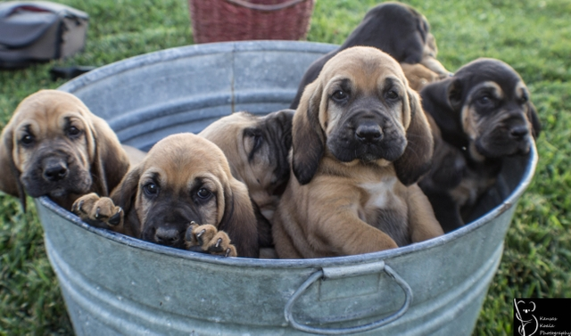

**Tentative Lecture Schedule**

##### **Date Lecture Topics Chapter**

**January 6** Introduction

The Study of Life 1

The Molecules of Cells 2

Cell Structure and Function 3

Membrane Structure and Function  4

Cellular Respiration 7

DNA Function and Protein Synthesis 25

#### January 21 Exam 1

Cell Division 5

Human Organization 11

### Nervous System 17

### Senses 18

**January 28 Exam 2**

### Skeletal System 19

### Muscle 19

Cardiovascular System 12

Respiratory System 15

### **February 6 Exam 3**

### Digestive System and Nutrition 14

### Urinary System and Excretion 16

### Reproductive System 21

**February 13 Final Exam**

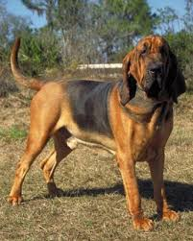

### **Tentative Lab Schedule**

##### **Date Topic Chapter**

January 6 **Scientific Method (Hand Out) 1**

Using the Scientific Method

Formulating Hypotheses

Performing the Experiment and

Coming to a Conclusion

January 7  **Metric Measurement and Microscopy 2**

The Metric System

January 8 **Metric Measurement and Microscopy 2**

Microscopy

Use of the Compound Light Microscope

Microscopic Observation (human epithelial cells)

January 9 **Chemical Composition of Cells 3**

Proteins

Carbohydrates

Lipids

January 13 **Cell Structure and Function 4** Prokaryotic verses Eukaryotic Cells

Animal and Plant Cell Structure

Tonicity in Cells (potato strips)

January 14 **How Enzymes Function** **6**

Effect of Temperature on Enzyme Activity

Effect of pH on Enzyme Activity

Factors That Affect Enzyme Activity (virtual lab)

January 15 Lecture Chapters 23/24

**Human Genetics**  21

Determining the Genotype

Determining the Inheritance

Genetic Counseling

Gametogenesis in Animals

January 16 **Animal Organization**  11

Tissue Level of Organization

**January 20 Holiday**

**January 21 Exam 1/Video**

January 22 **Mitosis and Meiosis**  5

**Patterns of Inheritance** 20

January 23 **Nervous System and Senses\***  17

Central Nervous System

Peripheral Nervous System

January 27 **Nervous System and Senses\***  17

The Human Eye

The Human Ear

Sensory Receptors in Human Skin

Human Chemoreceptors

**January 28 Exam 2/Video**

January 29 **Musculoskeletal System\***  18

Anatomy of a Long Bone

The Skeleton

January 30 **Musculoskeletal System\***  18

Mechanism of Muscle Fiber Contraction

The Skeletal Muscles

Mechanism of Muscle Fiber Contraction

February 3 **Homeostasis\***  16

Heartbeat and Blood Flow

Blood Flow and Systemic Capillary Exchange

February 4 **Homeostasis\***  16

Lung Structure and Human Respiratory Volume/ Kidneys

February 5 **Basic Mammalian Anatomy I* (Pig)**  12

Oral Cavity and Pharynx

Thoracic and Abdominal Incisions

Neck Region

Thoracic Cavity

Abdominal Cavity

**February 6 Exam 3/Video**

February 10 **Basic Mammalian Anatomy II* (Pig)**  15

Urinary System

Male Reproductive System

Female Reproductive System

February 11 **Review for Practical**

February 12 **Lab Practical**

**February 13** **Final Exam**

**\*=gloves required**

**\*\*\*If extra credit is earned\*\*\***

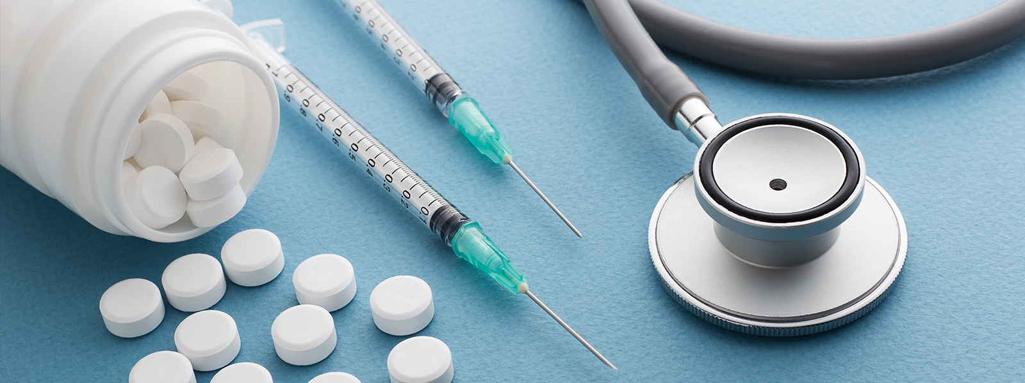

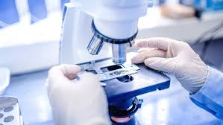

|  |  |
| --- | --- |
| **Date** | **Tentative Lecture Schedule** |
| Jan 6 | Study of Molecules |
| Jan 7 | Molecules of Life/Chemistry (through acid/base) |
| Jan 8 | Carbohydrates/Fats/ |
| Jan 9 | Proteins |
| Jan 13 | Cell Membrane/Passive/Active Transport |
| Jan 14 | Organelles/Glycolysis |
| Jan 14 | Citric Acid Cycle/ Electron Transport Chain |
| Jan 15 | DNA |
| Jan 16 | Protein Synthesis |
| **Jan 20** | **Holiday** |
| **Jan 21** | **Exam 1** |
| Jan 22 | Mitosis/Meiosis |
| Jan 23 | Neuron |
| Jan 23 | CNS/PNS |
| Jan 27 | Vision/Hearing |
| **Jan 28** | **Exam 2** |
| Jan 29 | Bone |
| Jan 30 | Muscle Video |
| Feb 3 | Cardiovascular System |
| Feb 3 | Blood Flow |
| Feb 4 | Conduction |
| Feb 5 | Respiration |
| **Feb 6** | **Exam 3** |
| Feb 10 | GI Video |
| Feb 11 | Urinary System Video |
| Feb 12 | Reproduction Video |
| **Feb 13** | **Final Exam** |